CENTRELINE TEA BROKERS LIMITED MOMBASA

# THE KENYA CROP AND WEATHER WEEK UPTO 9TH SEPTEMBER 2025

# EAST OF RIFT

# KIAMBU/MURANGA/NYERI/MERU/KIRINYAGA

Rainfall was recorded over several parts of this region.

Intermittent cloudiness was experienced in the mornings giving way to sunny intervals. Occasional afternoon showers were experienced over few places. Nights were partly cloudy with showers over few places.

Both daytime (maximum) and night-time (minimum) temperatures increased over most stations.



Crop harvest slightly increased.

# WEST OF RIFT

# NANDI/KERICHO/BOMET/KAKAMEGA/KISII

Most parts of the Highlands West of the Rift valley and Lake Victoria Basin received rainfall.

Morning rains were experienced over few places. Afternoon showers and thunderstorms occurred over few places, occasionally spreading to several places. Few places received night showers.

Both daytime (maximum) and night-time (minimum) temperatures increased over most stations.

Crop harvest increased.

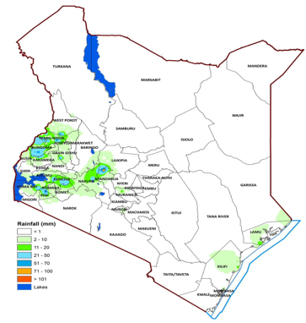

**9TH SEPTEMBER 2025**